Upgrades and Maintenance -- Ariel #336 (1965)

September, 2004

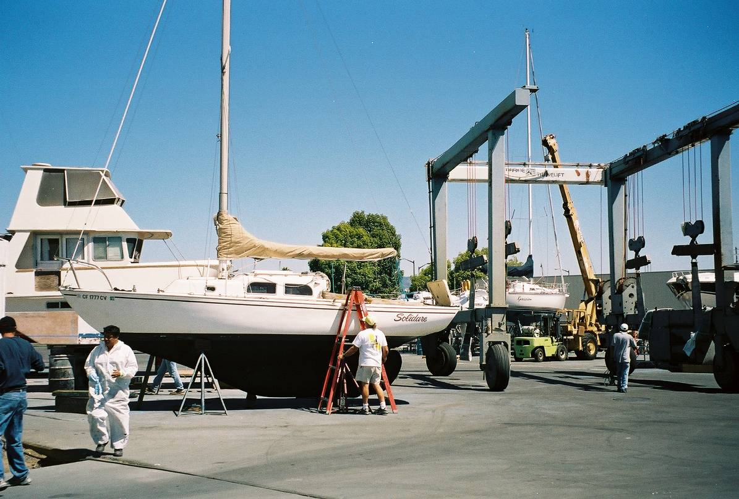

Purchased, hauled and surveyed. Replaced turn buckles, installed Marelon seacocks (no metal below water line except lower rudder fitting), new dock lines. New bottom paint.

November, 2004

New main halyard winch (Anderson # 10), deck mounted at aft end of cabin house.

April, 2005

Removed icebox, installed temporary chart table.

May, 2005

Refinished cockpit coamings and cabin sole.

June 2005

Purchased 2003 Pro Furl roller reefing with 2003 headstay, and recent working jib. Purchased new jib sock to protect jib when furled at dock.

July, 2005

Installed lazy jacks and new back stay (replaced original equipment insulated backstay with porcelain insulators for radio antenna)

August 2005

Serviced 6 hp Johnson outboard and had carburetor rebuilt.

